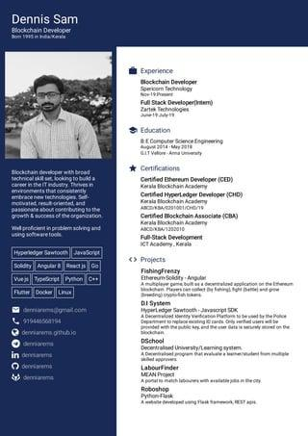
Dennis Sam
Blockchain Developer
Blockchain developer with broad technical skilooking to build a career in the IT industry Thrives i that consistently
Technologies Self-
vated, result oriented, and
ontributing to the
growth & success of the organization
Well proficient in problem solving and using software tools
Hyperledger Sawtooth JavaScript Solidity Angular
Reactjs Go
Veje TypeScript Python C
Flutter Docker Un
der@gmail.com
denniams github.io
in de
Experience Blockchain Developer Spericom Technology
Full Stack Developer) Zartes Technologies
Education
BEComputer Science Engineering
* Certifications
Certified Ethereum Developer (CED) Kerala Blockchain Academy
Certified HyperLedger Developer (CHD) Kerala Blockchain Academy AB/A/29101/CH/
Certified Blockchain Associate (CBA) Kerala Blockchain Academy ABCD/NA/1202010
Full-Stack Development ICT Academy.Kerala
<> Projects
Fishing Frenzy
Ethereum Soldity Angular
DI System
Hyperledger Sawtooth SDK
DSchool
Decentralised University/Learning system
LabourFinder
MEAN Project
Roboshop Python-Flask

